**Acute on chronic Subdural hematoma**

Acute on chronic subdural hematomas refers to a second episode of acute hemorrhage into a pre-existing chronic subdural hematoma. It typically appears as a hypodense collection with a **hematocrit level** (located posteriorly)

**Chronic Subdural hematoma**

(Hypodense)

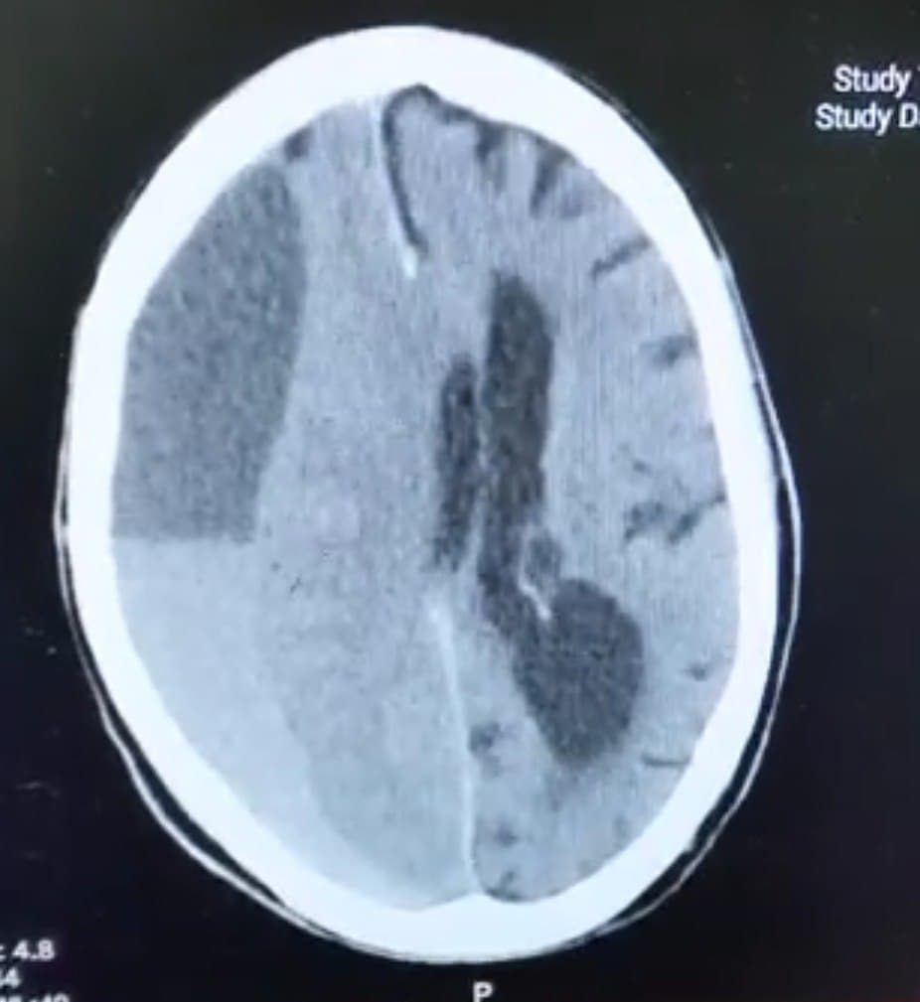

**Acute hemorrhage**

(Hyperdense)

**Hematocrit level**